|  |  |  |
| --- | --- | --- |
| **Report IDM reference No.** | EFDA_D_2MUYJL | **Version: see IDM** |

Final Report

on Deliverable

*MAT-1.2.1-T005-D001 - Summary overview report on EUROFER97 MPH developments for year 2016*

|  |  |  |  |
| --- | --- | --- | --- |
|  | | **Deliverable-ID**[1] | MAT-1.2.1-T005-D001 |
| **Work Package** | *WPMAT* | **Date** | *17.10.16* |
| **Project Leader** | *M. Rieth* | | |
|  | | | |
| **TS Title** | *PPPT Material Handbook 2016 (KIT - 2016)* | | |
| **TS Ref. No.** | *MAT-1.2.1-T005* | **TS IDM-link** | *https://idm.euro-fusion.org/?uid=2MLX44* |
| **Task Owner** | *Ermile Gaganidze* | | |
| **RU(s)** | *KIT* | | |

|  |  |
| --- | --- |
| **Report Review & Approval** | |
| **IDM role** | **Name(s)** |
| **Author** | *E. Gaganidze* |
| **Co-author(s)** |  |
| **Reviewer(s)** | *M. Gorley* |
| **PMU Reviewer** | *E. Diegele* |
| **Approver** | *M. Rieth* |

|  |  |  |  |  |  |
| --- | --- | --- | --- | --- | --- |
|  | Study / Assessment |  | Procurement / Commissioning of Hardware |  | Industry |

|  |  |  |  |
| --- | --- | --- | --- |
|  | Use of Facility | X | MPH development |

|  |
| --- |
| **Executive Summary** |
| *The main objective of the current work was the identification of the gaps in the 2015 version of MPH EUROFER97 chapter and proposal of improvements. A supporting document to the MPH has been prepared aiming at closing the known gaps by calculating the missing allowables. The shortcomings in the calculation of selected allowables in 2015 version have been eliminated by recalculations on the base of expert comments. New allowables and trend curves are included for reduction of area, fatigue crack growth and Larsen-Miller diagram. Depending on the data availability the influence of the irradiation is given for some properties in addition.* |

|  |
| --- |
| **Comments** (shortcomings, deviations, etc.) |
|  |

*{Guidance on Report format given below, this is not mandatory and can be modified as required}*

**Table of Contents**

1 Short Introduction and Objectives of Work 2

2 Filling the gaps in the 2015 version of EUROFER97 MPH 2

2.1 ERUOFER97 chemical composition 3

2.2 Uniform elongation unirradiated (average and minimum properties) 3

2.3 Total elongation irradiated (trend curves) 4

2.4 Reduction of Area (average and minimum properties) 6

2.5 Reduction of Area (irradiated trend curves) 7

2.6 Tensile strength (irradiated trend curves) 8

2.7 Fatigue-crack-growth rate (trend curves) 9

2.8 1% total strain limit 10

3 Conclusion 10

References 11

**Abbreviations**

|  |  |
| --- | --- |
| *DDC* | *DEMO Design Criteria* |
| *DEMO* | *Demonstration fusion reactor* |
| *EDDI* | *Engineering Design Data Integration* |
| *FCG* | *Fatigue Crack Growth* |
| *KIT* | *Karlsruhe Institute of Technology* |
| *MPH* | *Material Property Handbook* |
| *MTA* | *Hungarian Academy of Sciences* |
| *PPPT* | *Power Plant Physics and Technology* |
| *RAFM* | *Reduced Activation Ferritic/Martensitic* |

# Short Introduction and Objectives of Work

The 2015 version of MPH aiming at supporting of DDC activities has been successfully released in the frame of pilot project on EUROFER97. The MPH has been presented to the representatives of BB, DIV and MAT projects during the EDDI 2016 Workshop and distributed to the project and sub-project leaders as well as to selected experts outside EUROfusion community. The main objectives of the KIT activity within WP 2016 were preparation of the summary overview document aiming at filling the known gaps in the EUROFER97 MPH as well as eliminating the shortcomings in allowable calculations identified through the reviewing process. Organisational, content and editorial changes has been implemented via collaboration with MTA.

# Filling the gaps in the 2015 version of EUROFER97 MPH

The subsequent sub-chapters deal with the closing of shortcomings in the 2015 version of EUROFER97 MPH as well as with the calculation of new allowables.

## ERUOFER97 chemical composition

The chemical composition table of EUROFER97, see Table 1, included in the 2015 version of EUROFER97 MPH reproduced form (1) was found to have some inaccuracy with respect to the upper limits of radiologically undesirable elements e.g. Ni. Due to this reason the composition reported in (2) is proposed for the 2016 MPH version.

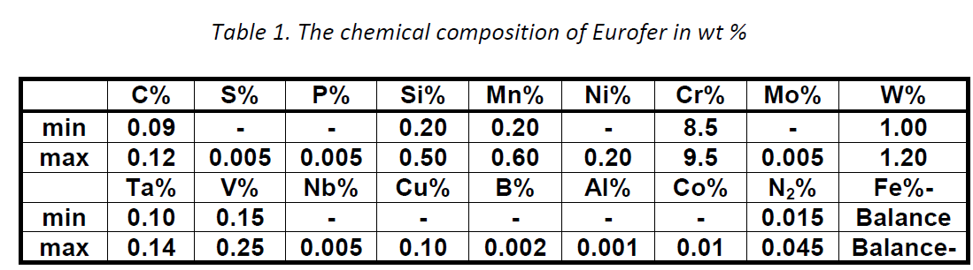

Table Chemical composition of EUROFER97 in wt % from (1) as included in 2015 MPH



Table Chemical composition of EUROFER97 in wt % from (2) to be included in 2016 MPH

## Uniform elongation unirradiated (average and minimum properties)

The ITER SDC-IC methodology used for calculation of the minimum uniform elongation (UE) curve for 2015 MPH version yielded non-physical values at test temperatures above 400 °C. Due to this reason an alternative approach is proposed for calculation of the minimum UE curve on the base of data available in (3), see also Figure 1.

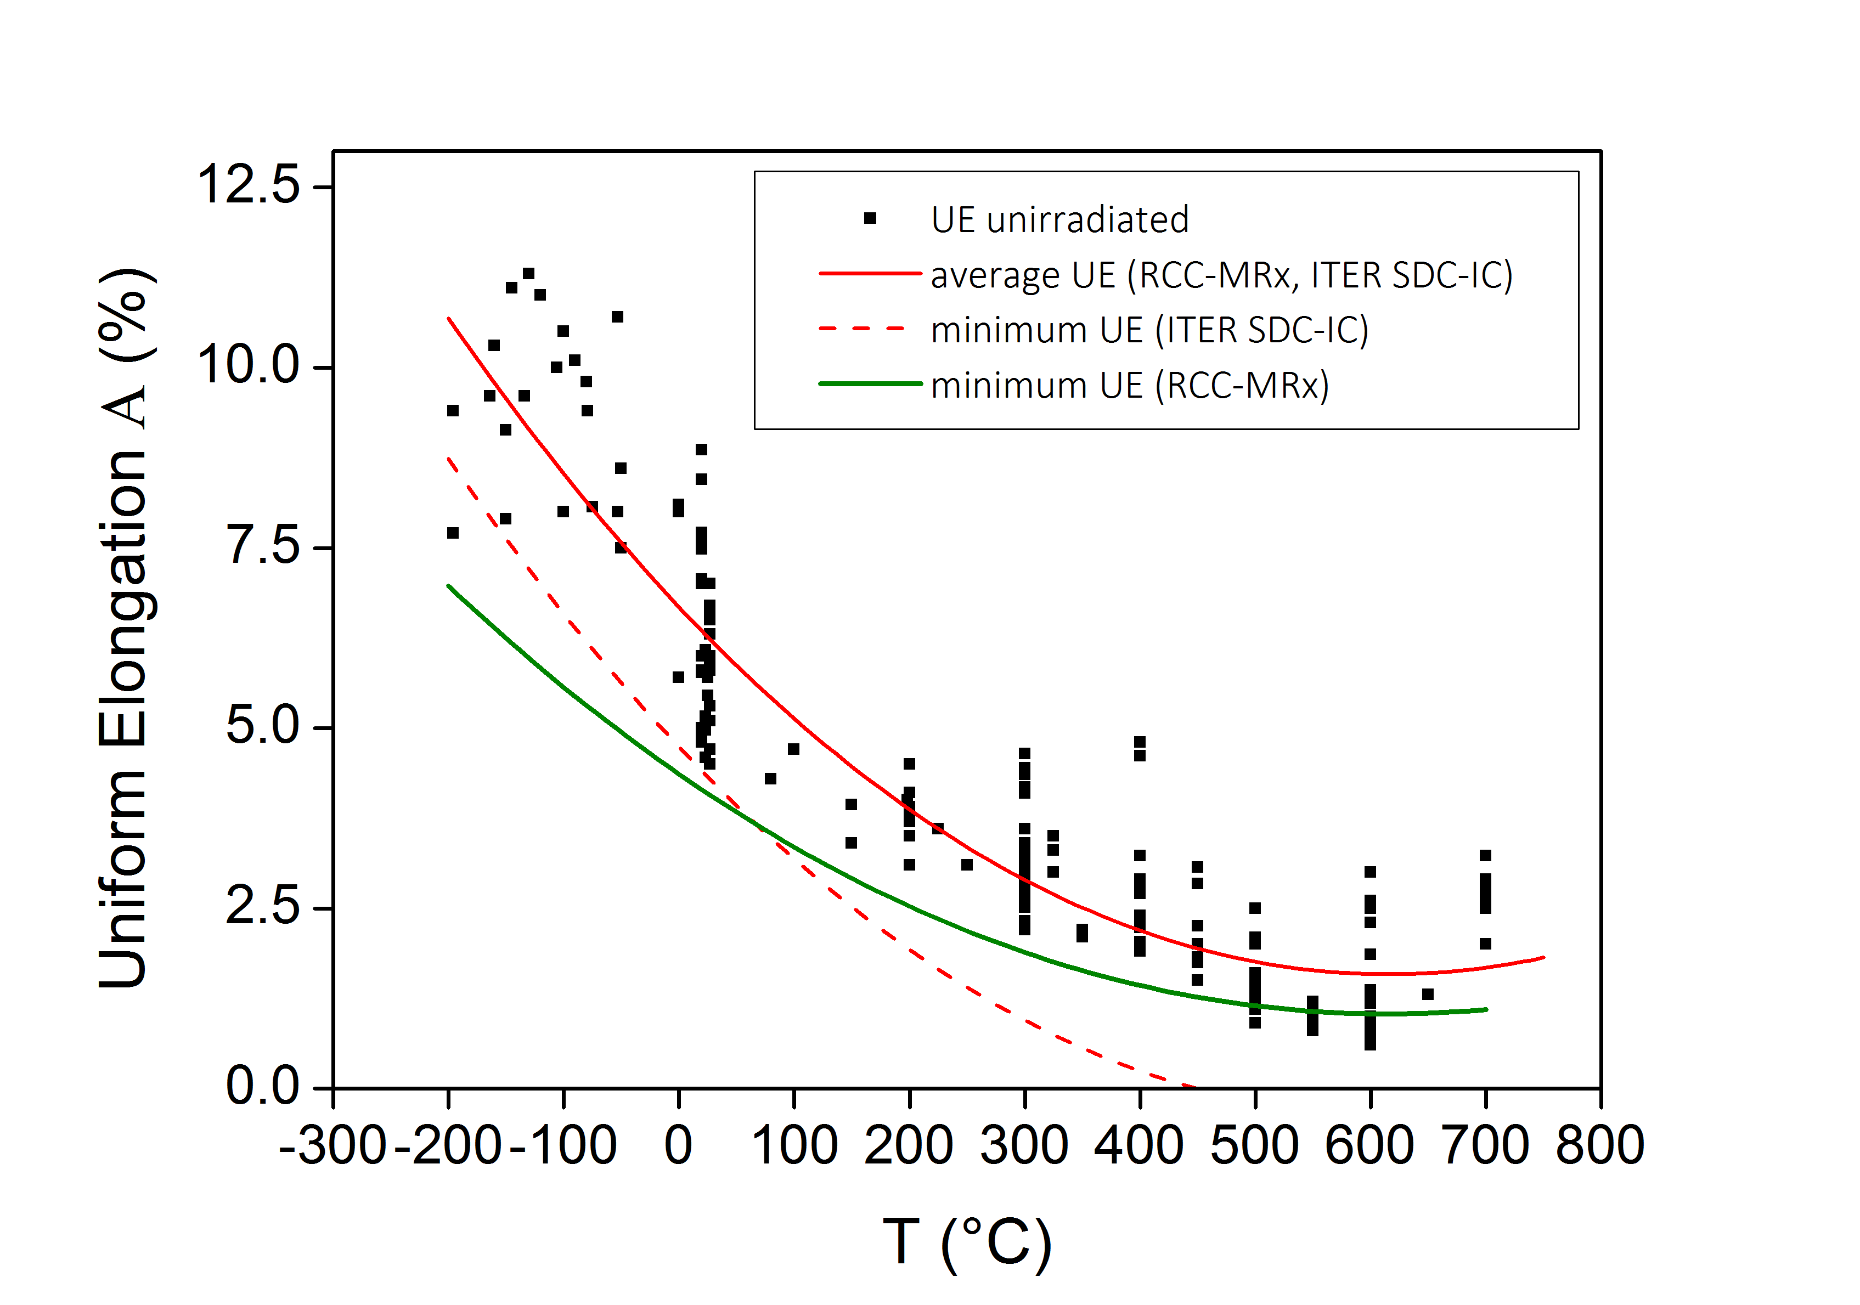

Figure Uniform elongation (UE) of the base metal EUROFER97 in the unirradiated state (squares). The red solid line is the mean value of the UE calculated by least square fitting of the experimental data with a polynomial of the 3rd order. The dashed red-line is the minimum UE curve calculated according to ITER-SDC methodology. The green solid line is the new minimum UE curve, see text.

Average value of the UE can be calculated according to ITER SDC-IC or 2012 AFCEN RCC-MRx methodologies by fitting the experimental data with a polynomial function. The third order polynomial function fitting of the data (red curve in Figure 1) provided the following fitting parameter:

Equation

with the standard deviation of σ= 0.9924% for the entire dataset.

The minimum value calculated for 2015 MPH according to ITER SDC-IC methodology by

Equation

yields however unphysical values above ~400°C (dashed red line in Figure 1).

The application of the 2012 AFCEN RCC-MRx methodology requires the knowledge of the RT value of minimum UE. In the EUROFER97 specification the minimum UE at RT is however not specified. Due to this reason the minimum UE at RT has been calculated by statistical procedure according with

Equation

here .

After determination the ${UE}_{av}\left(RT\right)$ the minimum UE has been calculated following the 2012 AFCEN RCC-MRx methodology according to

Equation

The corresponding curve (the green solid line in Figure 1) is proposed to be included in the 2016 version of the MPH.

## Total elongation irradiated (trend curves)

The Total Elongation (TE) trend curve for the irradiated state included in 2015 MPH version did not differentiate between differently irradiated EUROFER97 results. To differentiate between different doses and between different irradiation temperatures the trend curves have been calculated for EUROFER97 data from (3) as shown in Figure 2. The fitting functions for the temperature dependence of TE are given in Table 3. It has to be emphasized that the equations are valid only in the temperature ranges explicitly indicated in Table 3.

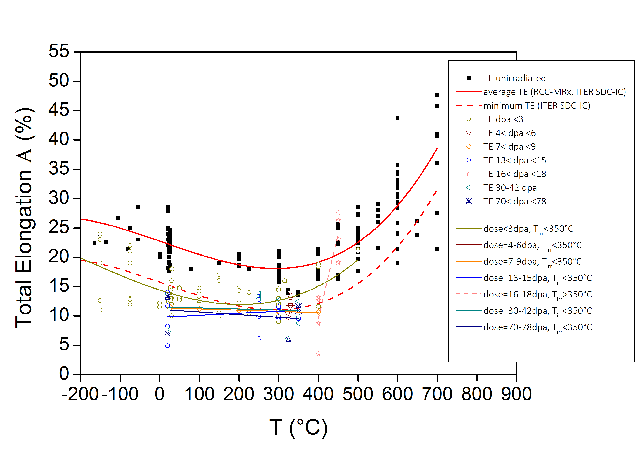

Figure Total Elongation of EUROFER97. Points: unirradiated and irradiated values. Lines: average and minimum Total Elongation (TE) curves in the unirradiated state together with trend curves for differently irradiated EUROFER97. The irradiated conditions are indicated in the figure legend.

|  |  |  |
| --- | --- | --- |
| **Condition, curve type** | **Temperature range** | **Fitting Equation** |
| **Unirradiated,**  **average TE** | **-164 ≤ T ≤ 700°C** | **22.75684-0.02355T-3.19787⋅10-6T2 +9.89573⋅10-8T3** |
| **Unirradiated,**  **minimum TE (ITER SDC-IC)** | **-164 ≤ T ≤ 700°C** | **22.75684-0.02355T-3.19787⋅10-6T2 +9.89573⋅10-8T3-1.96⋅3.58** |
| **Dose <3 dpa, Tirr<350°C,**  **trend curve** | **-150 ≤ T ≤ 500°C** | **14.41558-0.02209 T +3.77228⋅10-5 T 2 +5.41726⋅10-8 T 3** |
| **Dose =4-6 dpa, Tirr<350°C,**  **trend curve** | **320 ≤ T ≤ 340°C** | **11.825** |
| **Dose =7-9 dpa, Tirr<350°C**  **trend curve** | **20 ≤ T ≤ 400°C** | **11.4134-0.00214 T** |
| **Dose =13-15 dpa, Tirr<350°C**  **trend curve** | **20 ≤ T ≤ 350°C** | **9.77174+0.00338 T** |
| **Dose =16-18 dpa, Tirr≥350°C**  **trend curve** | **400 ≤ T ≤ 450°C** | **-106.3725+0.28975 T** |
| **Dose =30-42 dpa, Tirr<350°C,**  **trend curve** | **20 ≤ T ≤ 350°C** | **11.55066-0.00184 T** |
| **Dose =70-78 dpa, Tirr<350°C,**  **trend curve** | **20 ≤ T ≤ 350°C** | **11.11167-0.00449 T** |

Table Fitting functions for Total Elongation for EUROFER97 shown in Figure 2.

## Reduction of Area (average and minimum properties)

Figure 3 shows the Reduction of Area (Z) of EUROFER97 from (3) as a function of test temperature in the unirradiated condition. The open symbols show the results on the cylindrical specimens whereas the solid symbols represent the results where the geometry of the specimens is unknown. The latter results fell in the scatter band of the cylindrical specimens. Due to this reason it was decided to also include the specimens of the unknown geometry in the calculation of the average and minimum properties. It has to be emphasized that the approach followed above cannot be generalized and requires case by case study for the new data. For the upcoming testing campaigns it is therefore recommended to explicitly indicate the specimen geometry.

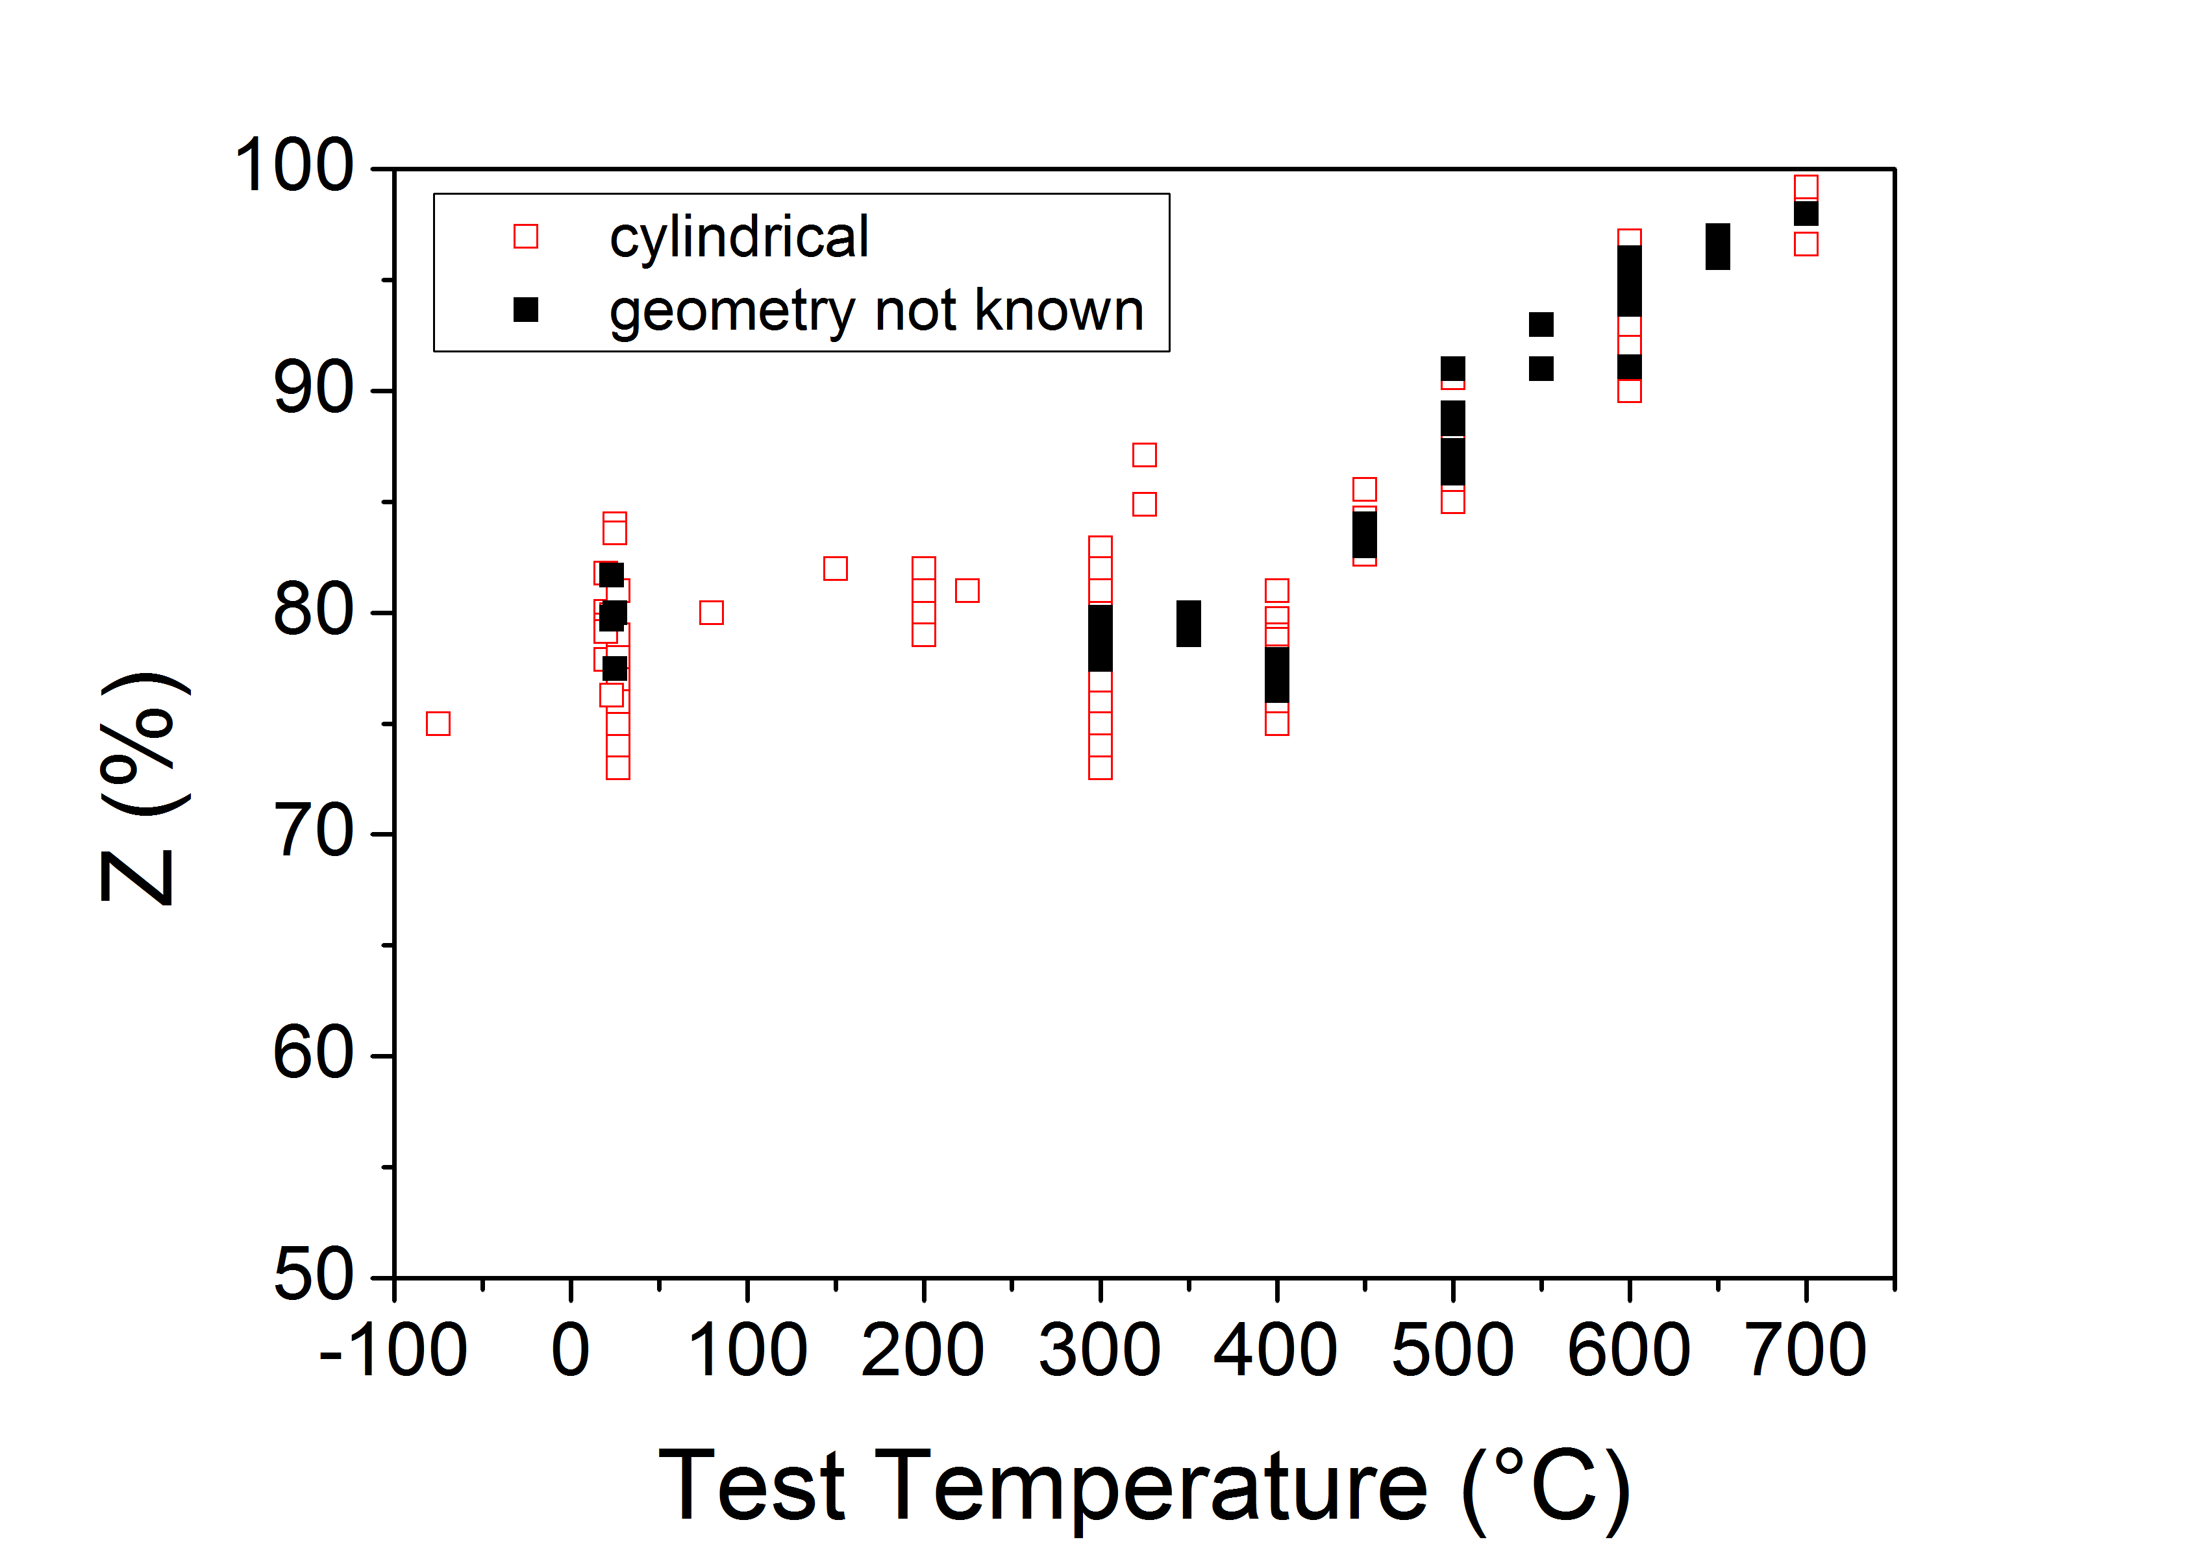

Figure Reduction of Area of EUROFER97 (unirradiated)

The average curve shown in Figure 4 was calculated by fitting the data with a polynomial of the 3rd order

Equation

The minimum curve shown in Figure 4 was calculated by applying the ITER SDC-IC methodology

Equation

with %.

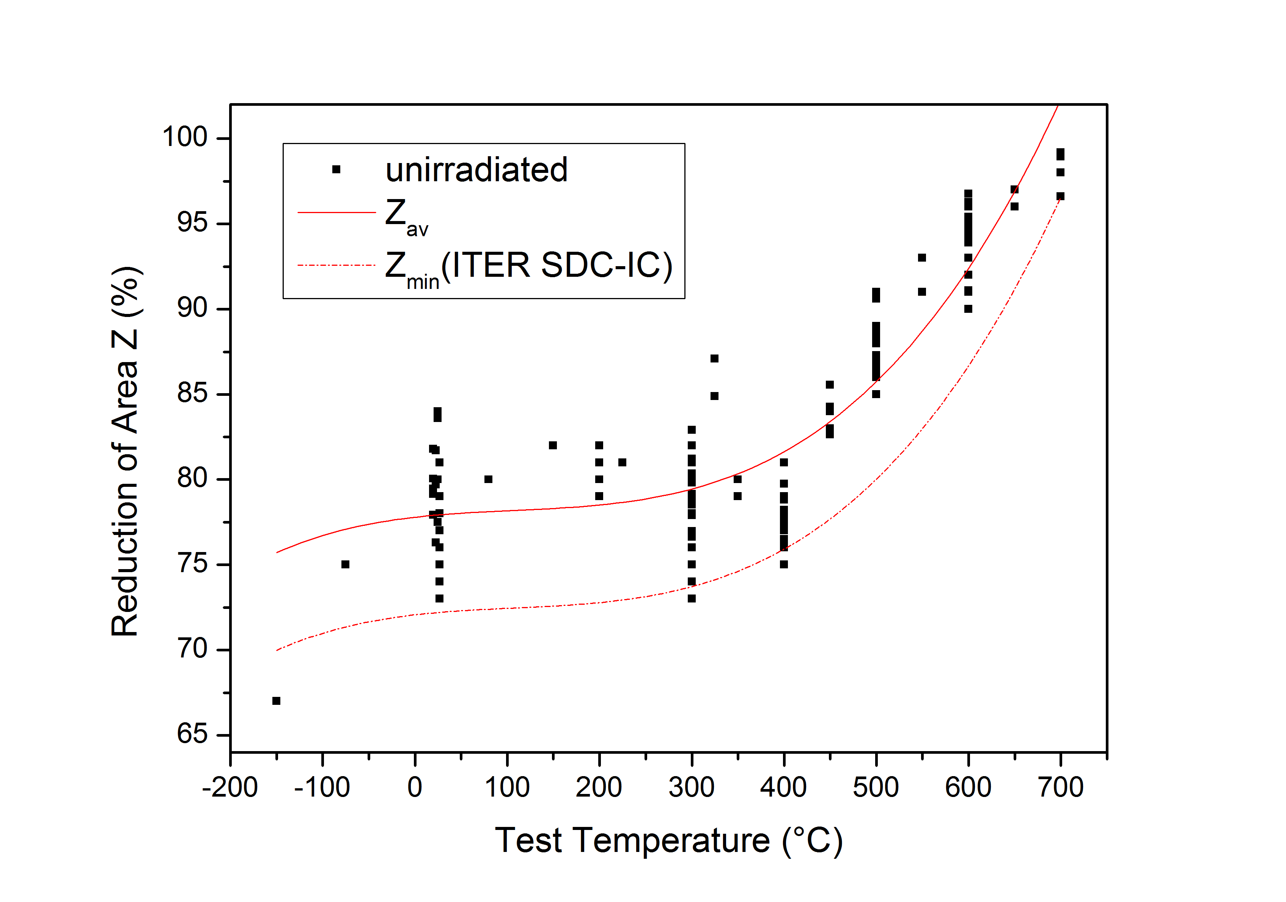

Figure Unirradiated average and minimum curves of Reduction of Area for EUROFER97.

## Reduction of Area (irradiated trend curves)

Within the EUROfusion database all irradiated Reduction of Area data are obtained on cylindrical specimens. The trend curves of the Reduction of Area in the irradiated state have been calculated by polynomial fitting of the differently irradiated data, see Figure 5.

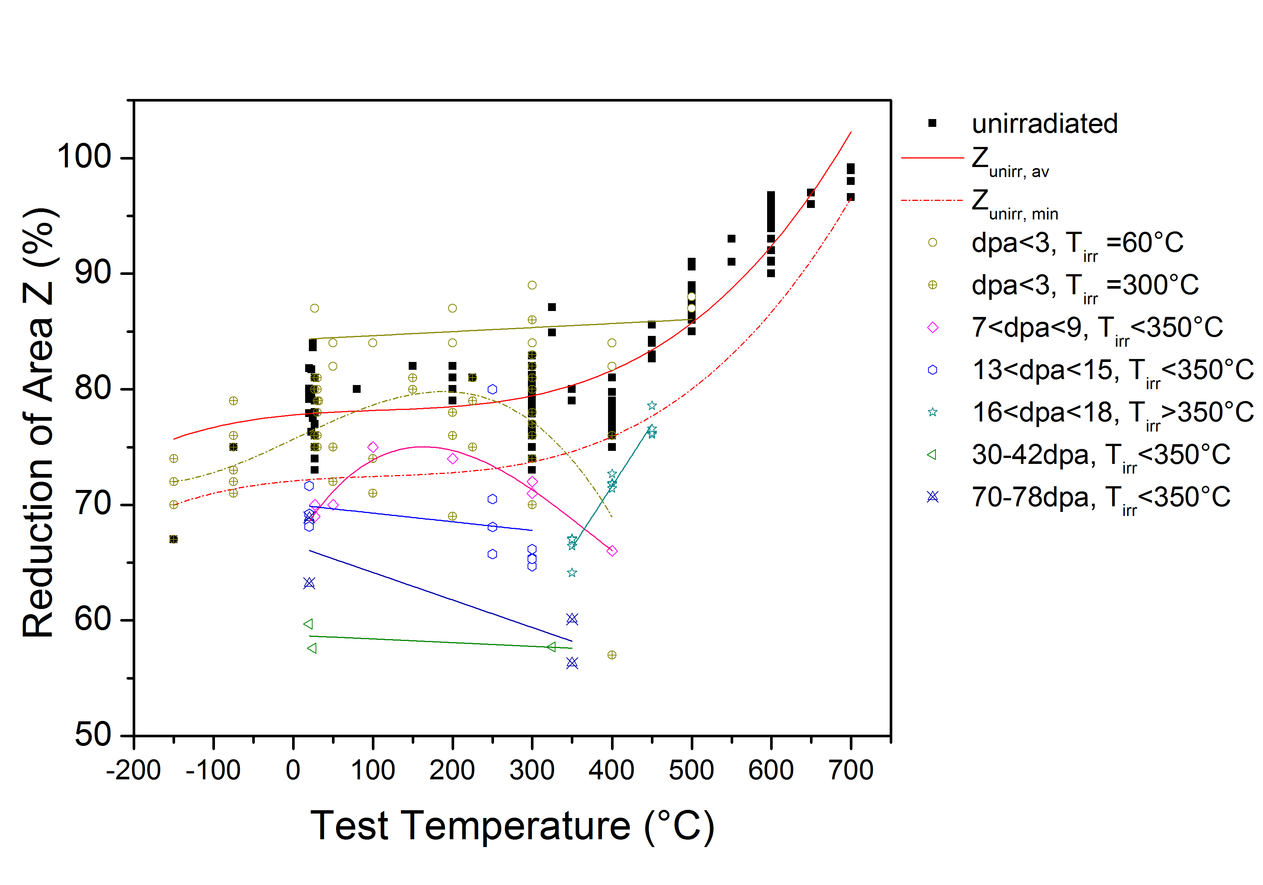

Figure Reduction of area in the unirradiated and irradiated state together with corresponding trend curves.

The fitting functions for the unirradiated and differently irradiated Reduction of Area are given in Table 4. It has to be emphasized that the equations are valid only in the temperature range explicitly indicated in Table 4.

|  |  |  |
| --- | --- | --- |
| **Condition, curve type** | **Temperature range** | **Equation** |
| **Unirradiated, average Z** | **-150 ≤ T ≤ 700°C** | **77.7929+0.0062T-3.482e-5T2**  **+1.085e-7T3** |
| **Unirradiated,**  **minimum Z (ITER SDC-IC)** | **-150 ≤ T ≤ 700°C** | **77.7929+0.0062T-3.482e-5T2**  **+1.085e-7T3-1.96*2.92** |
| **Dose <3 dpa, Tirr=60°C**  **trend curve** | **20≤ T ≤ 500°C** | **84.296+0.0035T** |
| **Dose <3 dpa, Tirr=300°C**  **trend curve** | **20≤ T ≤ 400°C** | **75.683+0.0324T+4.1006e-6T2**  **-3.18e-7T3** |
| **Dose =7-9 dpa, Tirr<350°C**  **trend curve** | **20 ≤ T ≤ 400°C** | **66.4584+0.1155T-4.51e-4T2**  **+3.99e-7T3** |
| **Dose =13-15 dpa, Tirr <350°C**  **trend curve** | **20 ≤ T ≤ 300°C** | **70.03-0.00748T** |
| **Dose =16-18 dpa, Tirr ≥350°C**  **trend curve** | **350 ≤ T ≤ 450°C** | **28.845+0.107T** |
| **Dose =30-42 dpa, Tirr <350°C**  **trend curve** | **20 ≤ T ≤ 350°C** | **58.72035-0.00319T** |
| **Dose =70-78 dpa, Tirr <350°C**  **trend curve** | **20 ≤ T ≤ 350°C** | **66.52576-0.02379T** |

Table Fitting functions for Reduction of Area of EUROFER97 shown in Figure 5.

## Tensile strength (irradiated trend curves)

Trend tensile strength properties of EUROFER97 have not been fully represented in the 2015 version of MPH. The missing trend curves have been calculated for differently irradiated EUROFER97, see Figure 6. The fitting equations for the trend curves are summarized in Table 5. The equations are valid only in the temperature range explicitly indicated in Table 5.

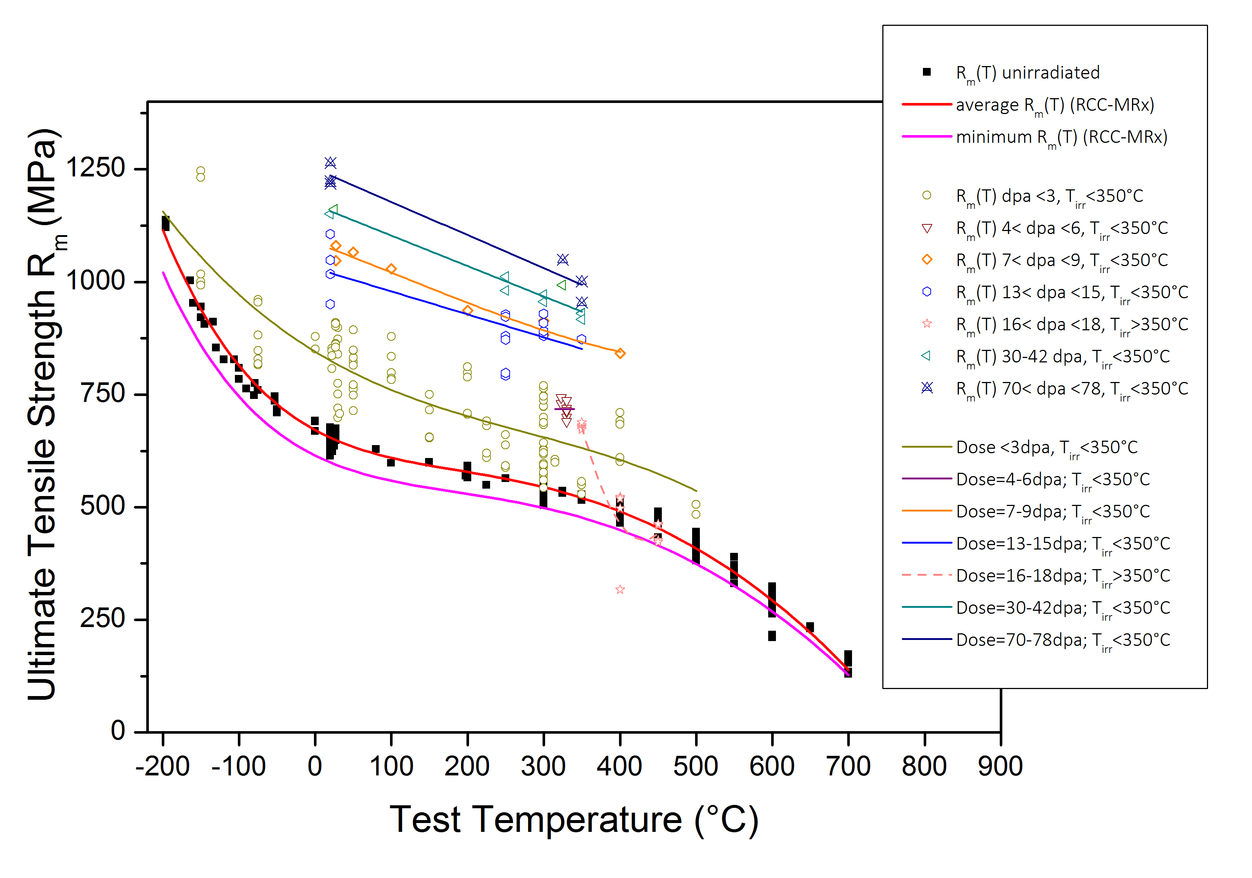

Figure 6 Tensile strength. Data points experimental results; lines average and minimum trend curves

|  |  |  |
| --- | --- | --- |
| **Condition, curve type** | **Temperature range** | **Equation** |
| **Unirradiated, average Rm** | **-200 ≤ T ≤ 700°C** | **671.31076-0.91828T+0.00397T2-1.04272E-5T3+1.02617E-8T4**  **-4.29924E-12T5** |
| **Unirradiated,**  **minimum Rm (RCC-MRx)** | **-200 ≤ T ≤ 700°C** | **(600/655.25149)*(671.31076-0.91828T+0.00397T2-1.04272E-5T3 +1.02617E-8T4-4.29924E-12T5)** |
| **Dose <3 dpa, Tirr<350°C,**  **trend curve** | **-200≤ T ≤ 500°C** | **845.38626-1.03298T+0.00209T2-2.52175E-6T3** |
| **Dose =4-6 dpa, Tirr <350°C,**  **trend curve** | **320≤ T ≤340°C** | **718** |
| **Dose =7-9 dpa, Tirr <350°C,**  **trend curve** | **20 ≤ T ≤ 400°C** | **1086.91898-0.62961T-4.19386E-4T2 +1.20197E-6T3** |
| **Dose =13-15 dpa, Tirr <350°C,**  **trend curve** | **20 ≤ T ≤ 300°C** | **1030.08498-0.50957T** |
| **Dose =16-18 dpa, Tirr ≥350°C,**  **trend curve** | **350 ≤ T ≤ 450°C** | **7663.2325-33.62398T+0.03906T2** |
| **Dose =30-42 dpa, Tirr <350°C,**  **trend curve** | **20 ≤ T ≤ 350°C** | **1170.52404-0.6751T** |
| **Dose =70-78 dpa, Tirr <350°C,**  **trend curve** | **20 ≤ T ≤ 350°C** | **1250.91507-0.73317T** |

Table Fitting functions for the tensile strength of EUROFER97 presented in Figure 6.

## Fatigue-crack-growth rate (trend curves)

Fatigue-crack-growth property chapter was already prepared in the 2015 MPH version. The experimental data available in the literature (4) and particularly the calculated trend curves for crack growth rates at different temperatures for two R=Fmin/Fmax values is proposed to be included in the 2016 MPH version. K-Decreasing procedure described in (5) has been used for determination of crack-growth rates and the fatigue crack threshold ΔKth. Figure 7 shows the trend curves as calculated in (4) by fitting the experimental data according to Equation 7.

|  |  |
| --- | --- |
|  |  |

Figure Trend curves of fatigue crack growth rate vs. stress intensity factor for EUROFER97 from (4).

Equation

The fitting parameters $A,$ $∆K^{n}, ∆K_{th}^{n}$ are summarized in Table 6.

|  |  |  |  |  |
| --- | --- | --- | --- | --- |
| T (°C) | R=Fmin/Fmax | (MPa m1/2) | A (mm/(cycle (MPa m1/2)n)) | n |
| RT | 0.1 | 9.02 | 6.16E-05 | 0.423 |
| 300 | 0.1 | 7.84 | 1.95E-08 | 2.541 |
| 500 | 0.1 | 7.57 | 7.44E-05 | 0.485 |
| 550 | 0.1 | 6.98 | 4.37E-03 | 0.027 |
| RT | 0.5 | 4.73 | 2.86E-08 | 2.445 |
| 300 | 0.5 | 5.23 | 8.42E-08 | 2.211 |
| 500 | 0.5 | 5.15 | 3.67E-03 | 7.97E-03 |
| 550 | 0.5 | 4.59 | 5.21E-01 | 1.41E-04 |

Table Values of fatigue crack threshold $∆K_{th}^{n}$ and the parameters A and n in Equation 7 determined for EUROFER97 at different temperatures and R-Ratios from (4).

## 1% total strain limit

It is proposed to replace the Larsen-Miller (LM) diagram for 1% creep strain limit used in 2015 EUROFER97 MPH chapter with the LM diagram for 1% total strain limit, as the stress level leading to 1% total strain is required for the determination of St(θ,t) curves according to the 2012 AFCEN RCC-MRx methodology. The LM plot for 1% total strain is shown in Figure 8.

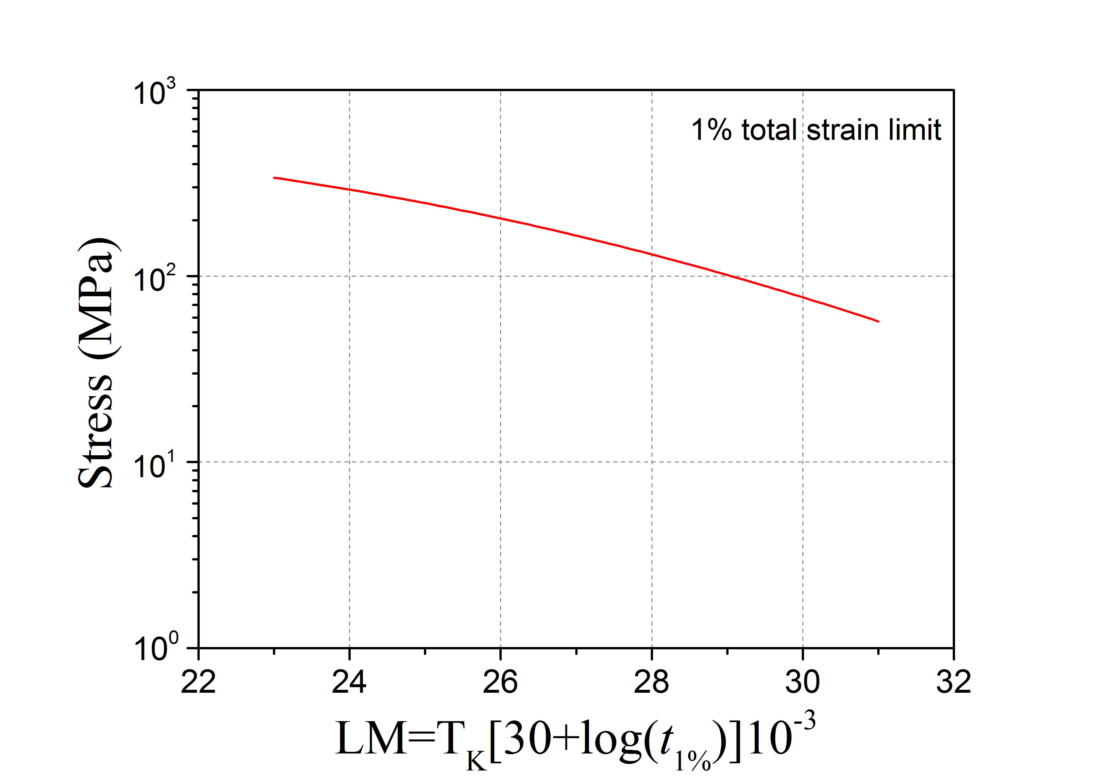

Figure 8 Larsen-Miller creep diagram for 1% total strain.

# Conclusion

A supporting document to the EUROFER97 MPH chapter has been prepared aiming at closing the known gaps by calculating the missing allowables. The shortcomings in the selected allowables in 2015 MPH version have been eliminated by recalculating the allowables on the base of expert comments. New allowables and trend curves are included for reduction of area, fatigue crack growth and Larsen-Miller diagram. Depending on the data availability the influence of the irradiation is given for some properties in addition.

# References

1. **F. Tavassoli.** *Comparison of 316L(N) -IG and Eurofer for Early DEMO.* France : CEA, 2013.

2. **A. Moeslang, E. Diegele, M. Klimiankou, R. Laesser, R. Lindau, E. Lucon, et al.** Towards reduced activation structural materials data for fusion DEMO reactors. *Nucl. Fusion.* 2005, Vol. 45, pp. 649-655.

3. **E. Gaganidze and M.Walter.** *Structural Steels Database Development and Population.* KIT. 2015. Final Report on Deliverable MAT-1.2.2-T6-D1. IDM Reference No. 2MHACW.

4. **J. Aktaa, M. Lerch.** Near-threshold fatigue crack behaviour in EUROFER 97 at different temperatures. *Journal of Nuclear Materials.* 2006, Vol. 353, pp. 101-108.

5. **E647, ASTM.** *Standard Test Method for Measurement of Fatigue Crack Growth rates.*

1. One *Deliverable Report* shall be submitted for each deliverable e.g. Study Report, Commissioning Report, Final Assessment Report, Technical Acceptance Report, Procurement Report, etc.